February 2020, Poznań

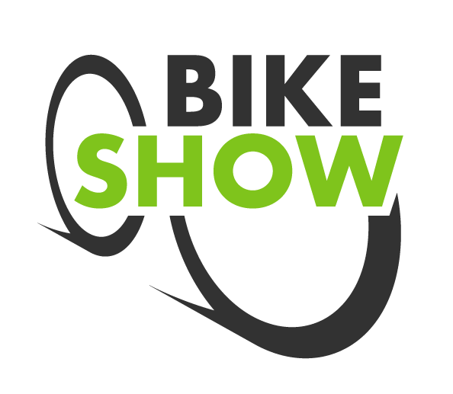

BIKE SHOW 2020
Testing cycling equipment, demonstrations of champions, stories of extraordinary cycling trips, games, shopping area, and a huge dose of positive emotions − this will be year's edition of BIKE SHOW to be held this year on April 3-5 simultaneously with POZNAN SPORTS EXPO.

New date
Spring is the time when the vast majority of enthusiasts of biking trips dig out their cycling equipment to draw energy from time spent on the road on two wheels for the next few months. Along with a touch of spring, the BIKE SHOW will let you prepare for the cycling season, and those who are still hesitating will catch the bug and see that cycling is fun, endorphins and eco style.

Formula
All days of the BIKE SHOW will be dedicated to the general public. A huge test track will be created, where everyone will be able to test some models of bicycles. The fair will be co-created by the manufacturers and distributors of equipment such as scooters, longboards, unicycles, skateboards or roller skates. There will also be special guests: champions of bike stunts, travellers, experts.

The power of a good connection
The BIKE SHOW will be held together with POZNAN SPORTS EXPO creating the largest sports festival in Wielkopolska. The quintessence of this merger will be the duathlon for children, which will be held on Saturday, April 4, on MTP Poznan Expo fairgrounds.
- Running and cycling are the most frequently chosen activities that support us in the fight for good shape and well-being. By combining BIKE SHOW and SPORTS EXPO POZNAN we want to create an energetic space that will develop both passions, activate those who still have a lot of excuses to stay at home, and open our guests to new sports challenges. Our events will also feature zones presenting other disciplines. Volunteers will be able to try their hand, for example at skating or roller skating. − says Dagmara Suprun, BIKE SHOW and SPORTS POZNAN EXPO Project Director.

More information: www.bikeexpo.pl.

